Prior Knowledge Review – Human Interaction
Mark Scheme
- Use the following food web to answer the questions:
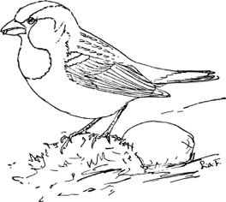
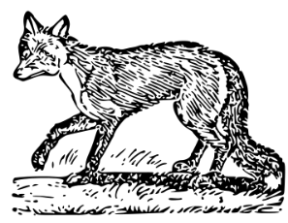
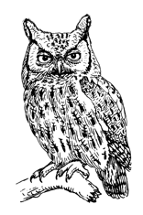
Owl
Sparrow
Fox

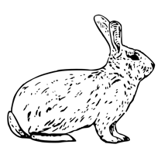
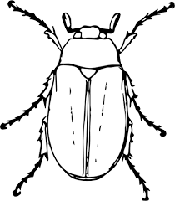
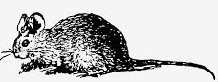
Mouse
Rabbit
Beetle

Lettuce
Seeds
Grass
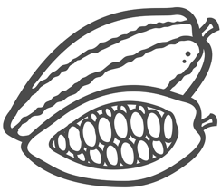
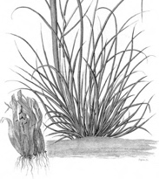
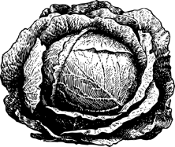

- Identify any producers (circle the name of the species in green).
Lettuce, grass and seeds (which are from fruit plants)
- Identify any primary consumers (circle the name of the species in blue).
Rabbit, mouse, beetle, sparrow
- Identify any secondary consumers (circle the name of the species in black).
Fox, owl, sparrow
- Identify any predators (put a black dot next to the name of the species).
Fox, owl, sparrow
- Identify any prey (put a blue dot next to the name of the species).
Rabbit, mouse, beetle
- Determine which species are herbivores (draw a square around the name of the species).
Rabbit, mouse, beetle

- Determine which species are carnivores (draw a triangle around the name of the species).
Fox, owl, sparrow
- Describe what would happen if the population of rabbits was suddenly reduced.
- The foxes would have fewer rabbits to eat
- They would eat more mice
- The population of mice would decrease
- This could affect the population of owls
- Owls and foxes would be competing with each other more
- Owls would eat more beetles
- Population of beetles would decrease
- This could affect the population of sparrows
- There would be an increase in the growth of lettuce

- Describe the effects of introducing a new species of sparrow into this food web.

- Sparrows eat beetles and seeds
- There would be more competition for these resources
- The better competitor would survive and take the resources
- This could affect the population of existing sparrows
- The population of beetles would decrease
- This could affect the population of owls

- Explain what the arrows represent in a food chain or a food web.
The direction of energy transfer

- Plants and animals compete with each other for a number of resources.

  - State the resources that animals compete for.
Space, food and mates
  - State the resources that plants compete for.
Space, water, minerals and light

  - Explain the difference between biotic and abiotic factors.

Biotic factors are living things that can affect a community, abiotic factors are non-living.

  - Classify all factors from Q2a and Q2b as biotic or abiotic factors.
- Space – abiotic
- Food – biotic
- Mates – biotic
- Water – abiotic
- Minerals – abiotic
- Light – abiotic

Stretch activity
Some students are researching the biodiversity of a field that contains a large oak tree. They have hypothesised that there will be fewer plants growing in the area around the tree than anywhere else in the field. Suggest a method for them to test their hypothesis and suggest a reason for their hypothesis.

- They could use a transect – a straight line through the field
- They could use quadrats at regular intervals along the transect
- Count the number of plants in each quadrat
- Analyse the data to determine if there is a difference between the number of plants present in the different areas
- Their hypothesis is based on the theory that the tree will be outcompeting the plants for the available sunlight and it will have a deeper root system so will be able to absorb the available water

